
EGERTON UNIVERSITY

DEPARTMENT OF COMPUTER SCIENCE
[FACULTY OF SCIENCE]

PROJECT
ON

RAILWAY RESERVATION SYSTEM

BY
JAMES KARANJA

S13/03145/18

SUPERVISOR
Ms. NOELA

APRIL, 2023.

Table of Contents
1. Part one: PROJECT PROPOSAL 3
1.1 Aim of the project 3
1.2 Project Introduction 3
1.3 Project Objectives 3
1.4 Problem statement 4
1.5 Importance of the system 4
1.6 Limitations of the existing systems 5
1.7 Expected results 5
1.8 Challenges while creating the system 6
1.9 Work Schedule 6
1.10 Future Improvements 6
1.11 References 7
Part 2: SYSTEM REQUIREMENT SPECIFICATION(SRS) 8
2.1 Overall Description 8
2.1.1 Product Perspective 8
2.1.2 Product Functions 8
2.1.3 Functional Requirements 10
2.1.4 User Classes and Characteristics 11
2.1.5 Operating Environment 12
2.1.6 Design and Implementation Constraints 12
2.1.7 Project Documentation 12
2.1.8 User Documentation 13
2.1.9 Assumptions and Dependencies 13
2.1.10 External Interface Requirements 13
User Interfaces 13
Hardware Interfaces 13
Software Interfaces 14
Communications Interfaces 14
2.2 System Features 15
2.2.0 E-R Diagram 15
2.2.1 Use Case Scenarios 16
2.2.2 Activity Diagram 22
2.3 Other Nonfunctional Requirements 23
Part 3: SOFTWARE DESIGN DOCUMENT(SDD) 25
3.1 Introduction 25
3.1.1 Administrator Panel 25
3.1.2 Needs of Train Reservation System 25
3.1.3 Methodology Development Model 25
3.2 Tools and Technique 27
3.2 Specification Requirement 30
3.3 Architecture of the system 31
3.4 Task and Activities Performed 37
3.5.1 Structure of the project 37
Part 4: TEST PLAN AND TEST CASES 40
4.1 Introduction 40
4.2 Scope of project 40
4.3 Work plan 41
4.4 Test Plan and Strategy 41
Functional testing 41
4.5 The criteria of quality 42
4.6 Test Team Expectations 43
4.7. Responsibilities of Test Team Members 43
4.8. Deliverables 43
4.9 Test Cases 43
5. USER MANUAL 48
5.1 System Overview 48
5.2 System Requirements 49
5.3 System Features 50

Part one: PROJECT PROPOSAL

Aim of the project
The aim of the online train reservation system is to allow passengers to easily search, book, and manage their train tickets from the comfort of their own homes or offices. The system should provide an efficient and convenient way for passengers to check train schedules, availability, and fares, as well as make reservations and payments securely online.

Project Introduction
With the emergence of the online train reservation system, passengers can now easily book, manage and modify their train tickets from anywhere in the world with just a few clicks. Online train reservation system has transformed the way we travel by providing a seamless and convenient experience for passengers while reducing the administrative burden for train operators. This technology has not only made train travel more accessible and efficient but also enhanced the overall travel experience for passengers.

Project Objectives
- Streamlining the booking process: The primary objective of the online train reservation system is to simplify the booking process by allowing passengers to search for, book, and manage their train tickets easily and efficiently.
- Enhancing accessibility: Online train reservation system aims to make train travel more accessible by providing passengers with 24/7 access to train schedules, availability, and fares from anywhere in the world.
- Improving customer experience: Online train reservation system provides passengers with a more personalized experience by allowing them to select their preferred seats and other amenities to make their travel experience more comfortable.
- Real-time updates: The system provides real-time updates on train schedules and delays, allowing passengers to make informed decisions about their travel plans.
- Payment security: Online train reservation system ensures secure payment processing, protecting passengers' sensitive financial information.
- Data analysis: Train operators can use data collected from online train reservation systems to analyze customer preferences and make data-driven decisions to improve their services.

Problem statement
The traditional process of booking train tickets involves long queues, manual paperwork, and limited availability of information. This process can be time-consuming and inconvenient for passengers, while also posing operational challenges for train operators. In this context, the problem statement for an online train reservation system is to address the challenges posed by the traditional booking process and provide a more convenient, efficient, and reliable platform for passengers to book and manage their train tickets.

Importance of the system
- Convenience: The online train reservation system provides passengers with a convenient and accessible platform to book and manage their train tickets from anywhere, at any time. This saves passengers the trouble of physically visiting the station, waiting in long queues, and worrying about last-minute bookings.
- Operational efficiency: The system automates the booking and ticketing process, reducing the workload of staff and improving the accuracy and speed of the booking process. This, in turn, improves the operational efficiency of train operators.
- Real-time information: The system provides real-time information on train schedules, seat availability, and fare updates, enabling passengers to make informed decisions about their travel plans and avoid any last-minute surprises or inconveniences.
- Personalization: The system allows passengers to select their preferred seats, meals, and other preferences, providing a more comfortable and personalized travel experience.
- Revenue generation: The system enables train operators to offer additional services such as food and beverage, travel insurance, and seat upgrades, generating additional revenue streams while enhancing the passenger experience.

Limitations of the existing systems
- Technical glitches: Technical issues such as system failures, slow response times, and connectivity problems can impact the user experience and cause inconvenience to passengers.
- Digital divide: Not all passengers have access to the internet or the required technology to use the online reservation system, leading to inequality in access to train tickets.
- Security concerns: The online reservation system requires the exchange of sensitive personal and financial information, making it vulnerable to cyber-attacks and identity theft. This can cause a loss of customer confidence and lead to reputational damage for train operators.
- Limited payment options: The online reservation system may have limited payment options, leading to inconvenience for passengers who do not have access to certain payment methods.

Expected results
- Enhanced customer satisfaction: The online reservation system offers real-time information, personalized services, and additional options, resulting in a more convenient and comfortable travel experience for passengers.
- Improved operational efficiency: The online reservation system automates the booking and ticketing process, reducing the workload of staff and improving the accuracy and speed of the booking process. This results in more efficient operations and better resource management for train operators.
- Increased revenue: The online reservation system enables train operators to offer additional services and generate additional revenue streams, leading to increased profitability and sustainability.

Challenges while creating the system
- Complex system requirements: The online train reservation system must have a robust backend infrastructure that can handle large volumes of data, user traffic, and transactions. The system must also be able to integrate with other systems, such as payment gateways and customer relationship management (CRM) systems.
- Technical expertise: Developing an online train reservation system requires specialized technical expertise in areas such as software development, database management, and cybersecurity. Finding skilled developers and maintaining the system can be a challenge for train operators.
- Data management: The online train reservation system must be able to manage large volumes of data, including passenger information, ticketing data, and operational data. Proper data management is critical to ensuring the security, privacy, and accuracy of the system.

Work Schedule
It is estimated to take around 8 weeks.

Future Improvements
- Artificial intelligence (AI) and machine learning: AI and machine learning can be used to personalize the online reservation experience for passengers by offering customized ticket prices, travel suggestions, and additional services based on their preferences and past travel history.
- Augmented and virtual reality: Augmented and virtual reality can be used to enhance the online booking experience by providing 3D views of train interiors, virtual tours of destinations, and interactive travel guides.
- Blockchain technology: Blockchain technology can be used to provide secure and transparent transactions, eliminating the need for intermediaries such as banks or payment processors.

References
- "A Comparative Study of Indian Railway Reservation System using Data Mining Techniques" by Nirmala Devi, K., et al. in the International Journal of Computer Applications. This paper analyzes the Indian railway reservation system using data mining techniques and provides insights into the system's performance and efficiency.

- "Railway Reservation System Upgrade to Boost Revenue and Passengers" by the Economic Times. This news article discusses the Indian railway reservation system's upgrade to a new technology platform, which is expected to improve the system's revenue and passenger volume.

- "How to Book Train Tickets Online on IRCTC" on the IRCTC website. This reference provides step-by-step instructions for booking train tickets online through the Indian railway reservation system.

- "Railway Reservation System in Japan" on the Japan Rail Pass website. This reference provides information on the Japanese railway reservation system, including schedules, fares, and ticketing options.

- "Amtrak Reservations" on the Amtrak website. This reference provides information on the Amtrak railway reservation system, including schedules, fares, and ticketing options for train travel in the United States.

Part 2: SYSTEM REQUIREMENT SPECIFICATION(SRS)

Overall Description

Product Perspective
The Train reservation system is a new self-contained software product which will be produced by the project team in order to overcome the problems that have occurred due to the current manual system. The newly introduced system will provide an easy access to the system and it will contain user friendly functions with attractive interfaces. The system will give better options for the problem of handling large scale of physical file system, for the errors occurring in calculations and all the other required tasks that has been specified by the client. The final outcome of this project will increase the efficiency of almost all the tasks done at the Station in a much convenient manner. The new project will be allowing for easier and credible retrieval of information in addition to providing efficient services.

Product Functions
- Book train tickets
- Manage ticket Details (Add, View, Update, Delete)
- Creates Accounts
- Manage Users (Add, View, Update, Delete)

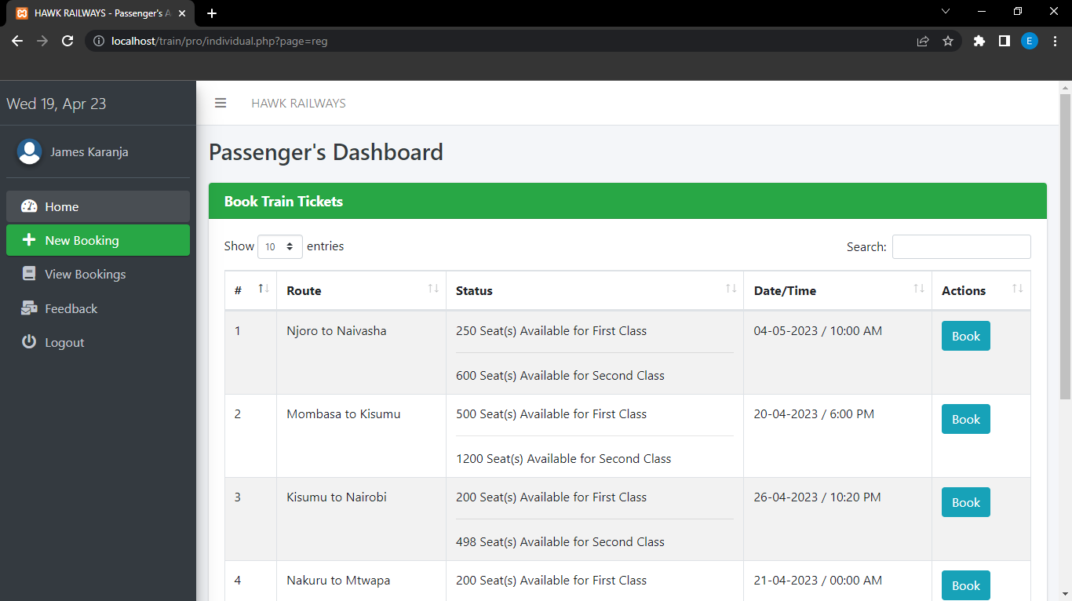

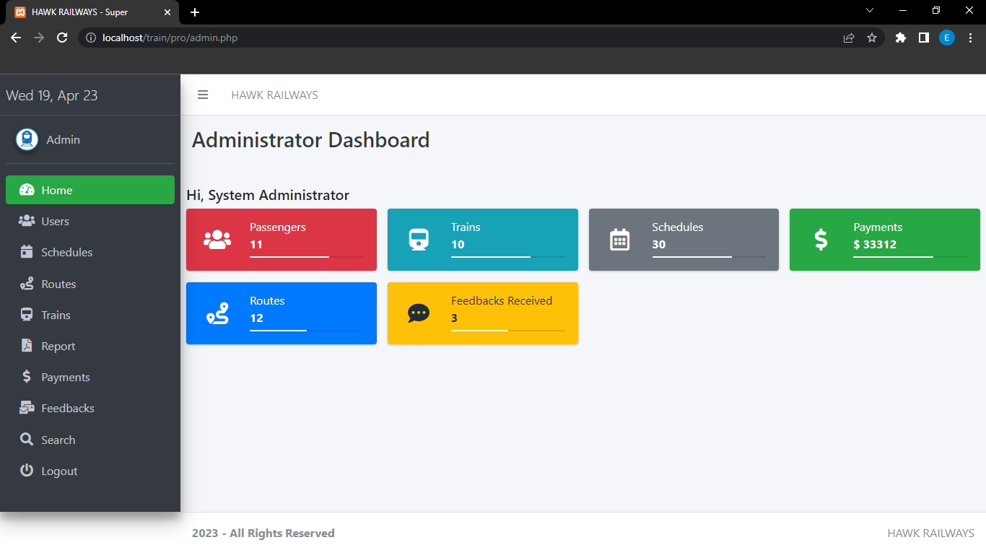

2.1.3 Functional Requirements

Function 1 | Booking Schedules
Input | phone number, Full Names, email address, check-in date, check out date, nationality
Output | Database Record, Database successfully updated message
Processing | Validate the given details and record the information in to the database.

Function 2 | Confirm Guest
Input | Phone number, Full Names, email address, check-in date, check out date,
Output | Database Record, Database successfully updated message
Processing | Validate the given details and record the information in to the database.

Function 4 | Search Schedules
Input | Period, Check-in, Check-out, Guest
Output | Display a message with available ticket details
Processing | Validate the given details and check for the available seats in a given time period and return its availability.

2.1.4 User Classes and Characteristics
User Classes
There are two user levels in the train ticket reservation System.
- Administrator
- Customer

Characteristics of User Classes
Administrator: -
Train reservation system admin has the privilege of Monitoring and authorization of all the tasks handle by the system. He can access every function performed by the system. Admin of the train’s system can have access to the administration panel which is consider the core of the system. As the main authorized person of the system admin gets the ability to manage the other users including their user levels and privileges. Manager has other abilities that Customer has. Such as Adding new guests to the system, modifying them and removing them from the system, adding new inventory to the system, modifying them and removing them. Adding new schedule types to the system, modifying them and removing them

User:
User is responsible for booking a train ticket online by checking on the available schedules.

Operating Environment
HARDWARE AND SOFTWARE REQUIREMENTS
HARDWARE REQUIREMENTS: -
- Operating System: Supports all known operating systems, such as Windows, Linux.
- Computer: 512MB+ RAM, monitor with minimum resolution of 1024x768, keyboard, and mouse.
- Hard Drive: Should be in NTFS file-system formatted with minimum 10 GB of free space.
- A Laser printer: Will need to be used to print these reports and notes

SOFTWARE REQUIREMENTS: -
- Software is designed to run on any platform above Microsoft Windows 7 (32bit). As well as Android and IOS via the browser.
- Microsoft .NET Frameworks 4.0 or above.
- Microsoft SQL Server Management Studio Express 2010.

Design and Implementation Constraints
Software development crew provides their best effort in developing the system. In order to maintain the reliability and durability of system, some design and implementation constraints are applied. Availability of an android app for hotel management system could make the system portable but due to time constraint it is not possible. System will need a minimum memory of 512MB. But it is recommended to have a memory of 1GB. When designing interfaces of system, we had the capability of work with new tools such as Dev Express. Considering the client’s budget, we decided to create those interfaces in a simple realistic manner using affordable technology.

Project Documentation
Project Documentation section reveals all the details concerning the document created by the project team. It includes the following
- Project Charter: - It provides the basic information about the team members that are responsible in the developing functions, the background of the client and of importance the nature of the main identified problem
- Project Proposal: - The proposal of the project consist the very problems identified by the client and the solutions that are implemented by the proposed system.

User Documentation
User documentation ideally contains the user manual that gives the user a clear guideline on how to interact with the system. It is normally written in understandable language and one that is simple. A hard copy of the user manual will be delivered to the client with the delivery of system.

Assumptions and Dependencies
Some of the software used to implement this given software is expensive and the client has agreed to be able to purchase it nonetheless. It’s assumed that client won’t change that decision on the next phases of the software development. It is also assumed that the client is using windows 7 or windows 8. In the event that the client uses an open-source operating system it is recommended to have changes in the SRS accordingly.

External Interface Requirements

User Interfaces
The system has a very good user interface that will allow the interaction between the user and the system at any given point in time. The log in interface will prompt the admin to enter his email address together with his password before log in to the landing page of the web-based application in play. The login will be for admin (from management).

Hardware Interfaces
In our section 2.4 the requirements of the desktop have been listed and hence the desktop connected to it must be able to meet the requirements or rather specifications.
The broadband internet connection. Client should be able to keep a stable internet connection.
In addition, a laser printer would be needed to print out reports and even various bills therein.

Software Interfaces
The computer this software going to be install need to have Windows Operating System equal or above, Windows 7. On that Windows platform .Net 4.0 will be installed and that will be the platform the particular software will be run. There will be an ADO.NET data transmission with the Microsoft SQL Server Management Studio Express 2010 R2 edition that will be installed in the same computer.

Communications Interfaces
Mostly a broadband connection with the client’s computer will provide the efficient service to allow the admin to view details of the other user level.

System Features

E-R Diagram
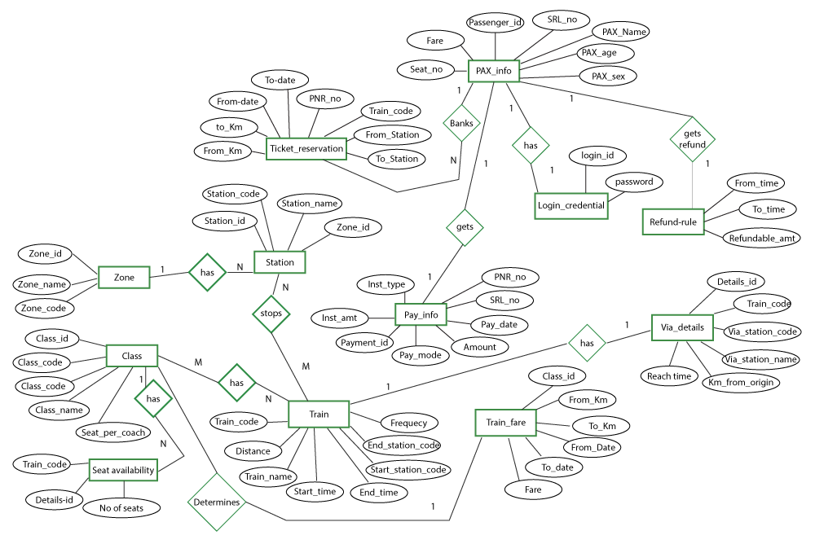

Use Case Scenarios
1)
Use case Name | Make Reservation
Goal | Add a new reservation
Primary Actors | Customer
Secondary Actors | None
Precondition | Guest should have an account
Post condition | Train Guest Details updated to include current Guest
Triggers
Main flow | Step | Action
Main flow | 1 | System searches for train details
Main flow | 2 | System presents schedule types and rates
Main flow | 3 | Customer selects train and confirms tariff
Main flow | 4 | System records customer’s name and address
Main flow | 5 | System generates confirmation
Extensions

2)
Use case Name | Check Availability
Goal | To check whether a room available or not
Primary Actors | Admin
Secondary Actors | None
Precondition | Login to the system.
Post condition
Triggers
Main flow | Step | Action
Main flow | 1 | Display User interface
Main flow | 2 | Select Availability Tab
Main flow | 3 | Enter train type
Main flow | 4 | System check schedule availability relevant to each requirement
Main flow | 5 | Display available room details
Extensions | 4.1 | No train available for entered details and display “No Train Available”

3)
Use case Name | Confirm Guest
Goal | Confirm a new Guest
Primary Actors | Admin
Secondary Actors | None
Precondition | Log in to the system
Post condition
Triggers
Main flow | Step | Action
Main flow | 1 | Admin selects “action” button
Main flow | 2 | System prompts to view all guest details
Main flow | 3 | System validates details
Main flow | 4 | Update database
Main flow | 5 | Display “Successful message”
Extensions

Extensions | 3.1 | Guest details are incorrect, Display the message "Unsuccessful" and display Add guest option.

4)
Use case Name | Add Schedule
Goal | Add a new schedule to the system
Primary Actors | Admin
Secondary Actors | None
Precondition | Log in to the system
Post condition
Triggers
Main flow | Step | Action
Main flow | 1 | Admin clicks “add train” button
Main flow | 2 | System prompts the manager to fill out train details
Main flow | 3 | System validates new train information
Main flow | 4 | System creates a new schedule
Main flow | 5 | Update database
Main flow | 6 | Display “successful” message
Extensions

Extensions | 3.1 | Train details are incorrect, Display the message "Unsuccessful" and display room management option.

5)
Use case Name | Delete schedule
Goal | Delete a schedule from the system
Primary Actors | Admin
Secondary Actors | None
Precondition | Log in to the system
Post condition
Triggers
Main flow | Step | Action
Main flow | 1 | User select “delete ticket” option
Main flow | 2 | Display delete ticket option
Main flow | 3 | User select the ticket
Main flow | 4 | System display confirm message
Main flow | 5 | User select confirmation
Main flow | 6 | Update database
Main flow | 7 | Display “successful message’
Extensions

Extensions | 4.1 | If user select “Yes” details are remove from the database. Else cancel the process

6)
Use case Name | Edit schedule details
Goal | Alter details such as view or type of train
Primary Actors | Admin
Secondary Actors | None
Precondition | Log in to the system
Post condition
Triggers
Main flow | Step | Action
Main flow | 1 | Admin selects “change train details”
Main flow | 2 | System prompts manager to select train
Main flow | 3 | Manager select the train
Main flow | 4 | System display train details
Main flow | 5 | Manager edit train details
Main flow | 6 | System alters train details
Main flow | 7 | Update database
 | 8 | Display “successful” message
Extensions

Activity Diagram
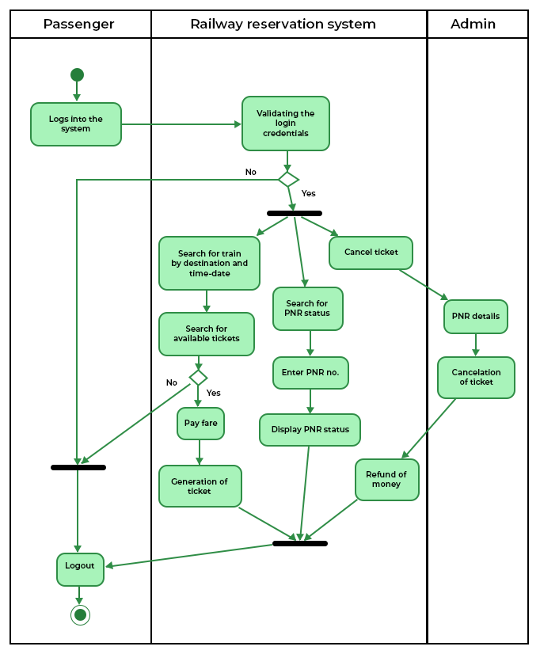

Other Nonfunctional Requirements
Performance Requirements
Performance requirements define acceptable response times for system functionality. Although the system is developed suiting for the least system performances, the performance of the system will highly depend on the performance of the hardware and software components of the installing computer. When consider about the timing relationships of the system the load time for user interface screens shall take no longer than two seconds. It makes fast access to system functions. The log in information shall be verified within five seconds causes’ efficiency of the system. Returning query results within five seconds makes search function more accurate.
Safety Requirements
There are several user levels in the train reservation system, Access to the various subsystems will be protected by a user log in screen that requires a user name and password. This gives different views and accessible functions of user levels through the system. Maintaining backups ensure the system database security. System can be restoring in any case of emergency.
Security Requirements
Customer and Managers will be able to log in to the Hotel Reservation System. Customer Service Representatives will have access to the Reservation/Booking and subsystems. Managers will have access to the Management subsystem as well as the Reservation/Booking subsystems. Access to the various subsystems will be protected by a user log in screen that requires a user name and password.

Software Quality Attributes
- Availability: - The system shall be available during normal train station operating hours
- Correctness: - extent to which program satisfies specifications, fulfills user’s mission objectives
- Efficiency: - How much smaller number of resources and time are required to achieve a particular task through the system.
- Flexibility: - Ability to add new features to the system and handle them conveniently.
- Integrity: - How the system would insecure the information in the system and how it avoids the data losses. Referential integrity in database tables and interfaces
- Maintainability: - How easy is to keep the system as it is and correct defects with making changes.
- Portability: - The Train Reservation System shall run in any Microsoft Windows environment
- Reliability: - Specify the factors required to establish the required reliability of the software system at time of delivery. Mean time between failures and mean time to recovery
- Re usability: - What is the ability to use the available components of the system in other systems as well.
- Te stability: - Effort needed to test to ensure performs as intended
- Usability: - How easily a person can be taken the benefits of the system and the user friendliness.
- Robustness: – Strength of the system to handle system functions accurately and maintain the database without facing to unexpected failures
- Maintainability: – What design, coding standards must be adhered to exclusions created
Business Rules
Train Reservation System will perform under two users which are Manager and Customer. The system is designed in a way where responsibility and privileges are decreased in the order of manager and customer.
Other Requirements
When the system is completely developed and submitted to the client, few sessions will be required to make the users of the system understand about the functionality of it and some time to adapt to the system.

Part 3: SOFTWARE DESIGN DOCUMENT(SDD)

Introduction
Train Reservation System is a train reservation site script where site users will be able to search schedule availability with an online booking reservations system. Site users can also browse trains, view schedule inventory, check availability, and book reservations in real-time.
Site users enter travel date and destination then search for availability and rates. After choosing the right schedule in the wanted train – all booking and reservation process is done on the site and an SMS is sent to confirm the booking.

Administrator Panel
Account Manager
- Administrator – Administrator can manage administrator accounts and conform the rooms.
- Train Types – Administrator can define the type of trains in the station, train’s prices and upload an image for each train.
- Bookings – All booking and reservations made on the site are displayed with all booking details: arrival date, departure date, train name, train type, number of passengers, price.

Needs of Train Reservation System
This system will help administration to work easily. Because of its easy access and less time consuming. administration can get the information of the Users, Trains, Payments, etc. They do not have to search in the paper file for the log time. Members an easily handle the system.

Methodology Development Model

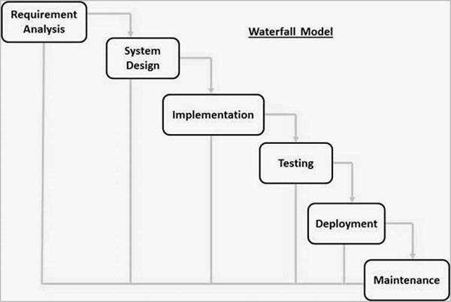

The sequential phases in Waterfall model are −
Requirement Gathering and analysis − All possible requirements of the system to be developed are captured in this phase and documented in a requirement specification document.
• System Design − The requirement specifications from first phase are studied in this phase and
the system design is prepared. This system design helps in specifying hardware and system
requirements and helps in defining the overall system architecture.
• Implementation − With inputs from the system design, the system is first developed in small
programs called units, which are integrated in the next phase. Each unit is developed and tested
for its functionality, which is referred to as Unit Testing.
• Integration and Testing − All the units developed in the implementation phase are integrated
into a system after testing of each unit. Post integration the entire system is tested for any faults
and failures.4
• Deployment of system − Once the functional and non-functional testing is done; the product is
deployed in the customer environment or released into the market.
• Maintenance − There are some issues which come up in the client environment. To fix those issues, patches are released. Also, to enhance the product some better versions are released.
Maintenance is done to deliver these changes in the customer environment

Tools and Technique
a. PHP
b. XAMPP
c. MySQL yog
d. HTML
e. Bootstrap
f. Sublime text
g. Git hub
h. Java Script
i. CSS
3.2.1 PHP
Hypertext Preprocessor (or simply PHP) is a server-side scripting language designed for Web development, but also used as a general-purpose programming language. It was originally created by Rasmus Lerdorf in 1994,] the PHP reference implementation is now produced by The PHP Group. PHP originally stood for Personal Home Page,] but it now stands for the recursive acronym PHP: Hypertext
Preprocessor.
PHP code may be embedded into HTML code, or it can be used in combination with various web template systems, web content management systems, and web frameworks. PHP code is usually processed by a PHP interpreter implemented as a module in the web server or as a Common Gateway Interface (CGI) executable. The web server combines the results of the interpreted and executed PHP code, which may be any type of data, including images, with the generated web page. PHP code may also be executed with a command-line interface (CLI) and can be used to implement standalone graphical applications.
3.2.2 XAMPP
XAMPP is a free and open-source cross-platform web server solution stack package developed by Apache Friends, consisting mainly of the Apache HTTP Server, MariaDB database, and interpreters for scripts written in the PHP and Perl programming languages. XAMPP stands for Cross-Platform (X), Apache (A), MariaDB (M), PHP (P) and Perl (P). It is a simple, lightweight Apache distribution that makes it extremely easy for developers to create a local web server for testing and deployment purposes. Everything needed to set up a web server – server application (Apache), database (MariaDB), and scripting language (PHP) – is included in an extractable file. XAMPP is also cross-platform, which means it works equally well on Linux, Mac and Windows. Since most actual web server deployments use the same components as XAMPP, it makes transitioning from a local test server to a live server extremely easy as well.
3.2.3 MySQL
MySQL Workbench is a unified visual tool for database architects, developers, and DBAs. MySQL Workbench provides data modeling, SQL development, and comprehensive administration tools for server configuration, user administration, backup, and much more. MySQL Workbench is available on Windows, Linux and Mac OS X.
3.2.4 HTML
Hypertext Markup Language (HTML) is the standard markup language for creating web pages and web applications. With Cascading Style Sheets (CSS) and JavaScript, it forms a triad of cornerstone technologies for the World Wide Web.
Web browsers receive HTML documents from a web server or from local storage and render the documents into multimedia web pages. HTML describes the structure of a web page semantically and originally included cues for the appearance of the document.
HTML elements are the building blocks of HTML pages. With HTML constructs, images and other objects such as interactive forms may be embedded into the rendered page. HTML provides a means to create structured documents by denoting structural semantics for text such as headings, paragraphs, lists, links, quotes and other items.
3.2.5 Bootstrap
Bootstrap is a free and open-source front-end framework for designing websites and web applications. It contains HTML- and CSS-based design templates for typography, forms, buttons, navigation and other interface components, as well as optional JavaScript extensions. Unlike many web frameworks, it concerns itself with front-end development only.
3.2.6 JavaScript
JavaScript often abbreviated as JS, is a high-level, interpreted programming language. It is a language which is also characterized as dynamic, weakly typed, prototype-based and multi-paradigm.
Alongside HTML and CSS, JavaScript is one of the three core technologies of the World Wide Web. JavaScript enables interactive web pages and thus is an essential part of web applications. The vast majority of websites use it, and all major web browsers have a dedicated JavaScript engine to execute it.
3.2.7 Sublime Text
Sublime Text is a proprietary cross-platform source code editor with a Python application programming interface (API). It natively supports many programming languages and markup languages, and functions can be added by users with plugins, typically community-built and maintained under free-software licenses.
GitHub
GitHub is a web-based hosting service for version control using Git. It is mostly used for computer code. It offers all of the distributed version control and source code management (SCM) functionality of Git as well as adding its own features. It provides access control and several collaboration features such as bug tracking, feature requests, task management, and wikis for every project.
GitHub offers plans for both private repositories and free accounts which are commonly used to host open-source software projects.
3.1.4.8. CSS
Cascading Style Sheets (CSS) is a style sheet language used for describing the presentation of a document written in a markup language like HTML. CSS is a cornerstone technology of the World Wide Web, alongside HTML and JavaScript.
CSS is designed to enable the separation of presentation and content, including layout, colors, and fonts. This separation can improve content accessibility, provide more flexibility and control in the specification of presentation characteristics, enable multiple web pages to share formatting by specifying the relevant CSS in a separate CSS file, and reduce complexity and repetition in the structural content.

Specification Requirement
External Interfaces
- This interface will be actual interface through which the user will communication with the application and perform the desired tasks.

Admin login
I.D:
Role: Admin wishes to login to the system
Precondition: Username and Password
Success end Condition: Main option of screen display
Failed end Condition: User has entered incorrect Username and
Password or both
ID:
Precondition: Admin has successfully navigated to the
search result
Success end Condition: Admin has successfully made the changes
Software Product Features
Train Reservation System
➢
- Sequencing information
-Login information should be filled before the user allowed.
➢
- Error Handling
-If user doesn’t filled up validate information then the system display error message for user and request to enter the validate information.

Performance required
- Security
-System should be Protected from unauthorized access Where the validate Username
and Password are required so no other can access.

Architecture of the system
LOGICAL DATABASE

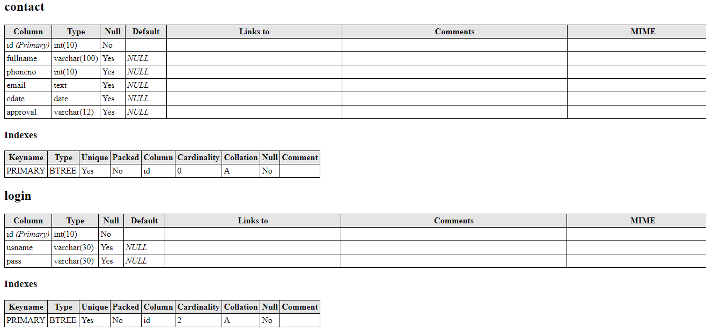
Data Design
Data Model: A database model is a type of data model that determines the logical structure of a database and fundamentally determines in which manner data can be stored, organized and manipulated.

LEVEL 0 DFD

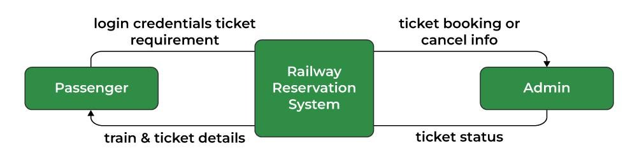

LEVEL 1 DFD
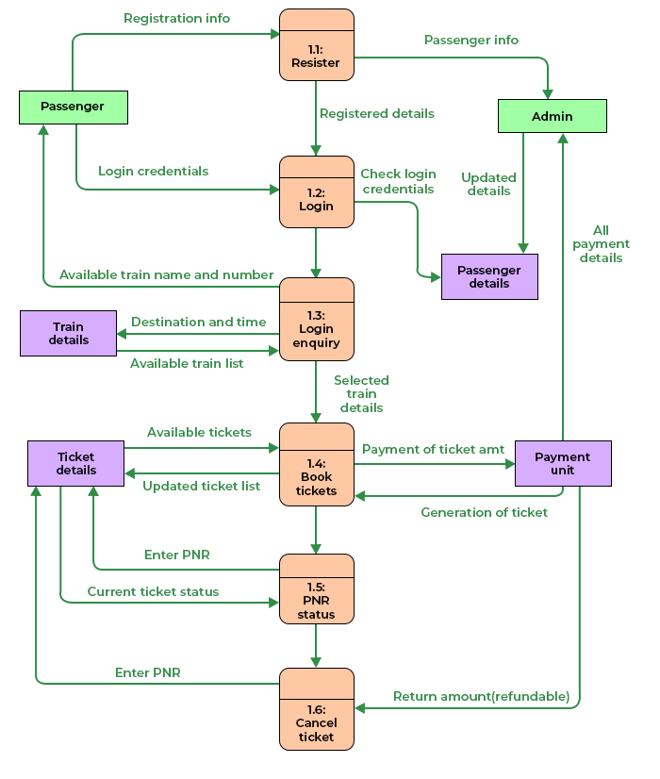

ER DIAGRAM
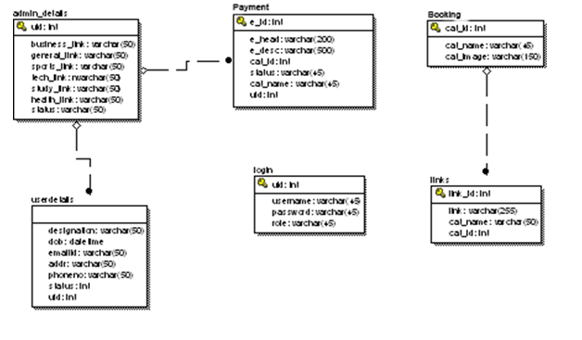

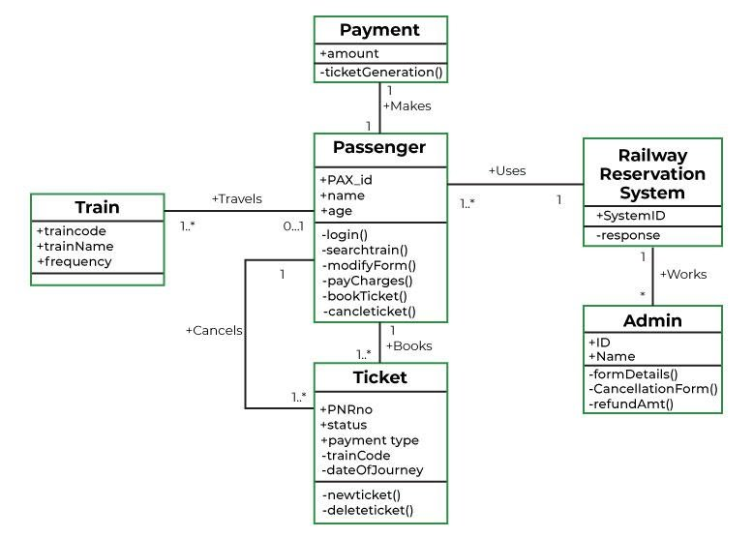

USE CASE DIAGRAM
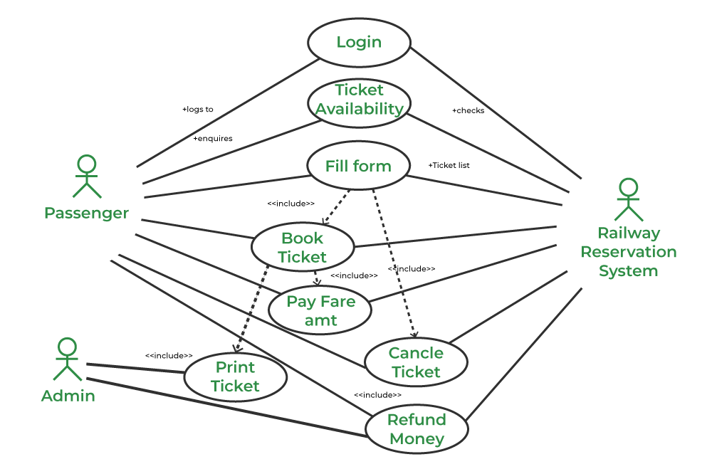

SEQUENCE DIAGRAM

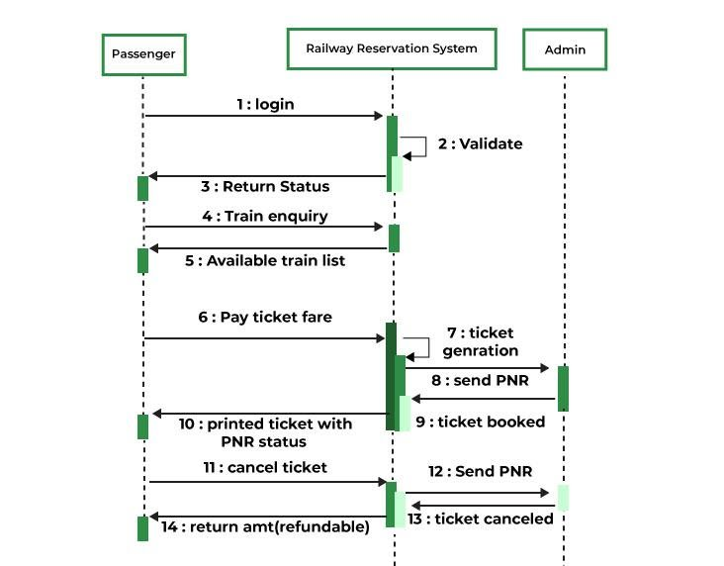

Task and Activities Performed
Advantage
- The advantages of booking a train online add up long before your arrival. Our legendary customer service extends to the web
- One advantage of booking with the station directly is the use of the station's full cancellation policy as well as not needing a deposit in most situations.
- Read reviews and compare prices for Online Train Ticket Booking.
- The most important advantage of online train booking is convenience, you can book your train by simply sitting in home. Internet helps you to browse through the hotels around the world and compare the facilities and rates easily.

3.5.1 Structure of the project
- After Administrator Login
- Status
- View Booking
- View Trains
- View payment’s
- News Letter
- Logout

- Users visit
- View schedules
- View Gallery
- View services
- Book

Scope and Feasibility
This activity is also known as the feasibility study. Perform and evaluate feasibility studies like cost-benefit analysis, technical feasibility, time feasibility and operational feasibility for the project. Project Scheduling should be made using chats. Feasibility study is carried out t decide whether the proposed system is feasible for the company. It begins with a request from the user for a new system. It involves the following:
- Identify the responsible user for a new system
- Clarify the user request
- Identify deficiencies in the current system
- Establish goals and objectives for the new system
- Determine the feasibility for the new system
- Prepare a project charter that will be used to guide the remainder of the Project

System Analysis
It is a process of collecting and interpreting facts, identifying the problems, and decomposition of a system into its components.
System analysis is conducted for the purpose of studying a system or its parts in order to identify its objectives. It is a problem-solving technique that improves the system and ensures that all the components of the system work efficiently to accomplish their purpose.
The objective of the system analysis activity is to develop structured system specification for the proposed system. The structured system specification should describe what the proposed system would do; independent of the technology, which will be used to implement these requirements.
The structured system specification will be used to implement these requirements.
The essential model may itself consist of multiple models, modeling different aspect of the system. The data flow diagrams may model the data and their relationships and the state transition diagram may model time dependent behavior of the system. The essential model thus consists of the following.
- Context diagram
- Leveled data flow diagrams
- Process specification for elementary bubbles
- Data dictionary for the flow and stores on the DFDs.

System Design
System design involves transformation of the user implementation model into software design.
The design specification of the proposed system consists of the following:
- Database scheme
- Sequence Diagram
Implementation
This activity includes programming, testing and integration of modules into a progressively more complete system. Implementation is the process of collect all the required parts and assembles them into a major product.
Test Generation
This activity generates a set of test data, which can be used to test the new system before accepting it. In the test generation phase, all the parts are come which are to be tested to ensure that system does not produce any error. If there are some errors then we remove them and further it goes for accepting.

Part 4: TEST PLAN AND TEST CASES

Introduction
General information
This document describes the methods and procedures that will be used by the group in the functional testing process of the Train Reservation System.
It is meant to be used as a manual during testing. It describes the procedure of the testing process.
The objective of the testing activities is to check functions and features of the System.
Purpose
This Test Plan document for the Hotel Management System supports the following objectives:
● Identify existing project information and software components to be tested.
● Recommendation and description of the testing strategies to be employed.
● Identify required resources and provide a test effort estimate
● List the test project deliverable elements.
The results of test execution will be noted and addressed by the respective group member developing the noted area.

Scope of project
Scope of Train Reservation System Test Plan.
The following components and functions would be tested:
- Check user interfaces.
- Create an account using email.
- Use Log in
- Viewing Schedules
- Cancelling booked trains.

Work plan
The parties agreed to follow the next work plan:
1. Test plan preparation
2. Test plan approval
3. Functional testing and bugs reporting
4. Daily reports preparation
5. Final report preparation

Test Plan and Strategy

Functional testing
The objective of functional testing is to make sure that the whole software product works according to the requirements, and no significant errors appear in the application.
Functional testing is the most substantial part of software testing. It involves checking different aspects of the system. A software product must pass all the planned tests. Only in this case its quality can be assured.
Test Objective | Ensure proper target-of-test functionality
Technique | Execute each use case, use-case flow, or function, using valid and invalid data, to verify the following:  ● The expected results occur when valid data is used.  ● The appropriate error or warning messages are displayed when invalid data is used.  ● Each rule is properly applied
Completion Criteria | ● All the planned tests are performed.  ● There are no show-stopping errors.  ● All the errors of high priority and severity are fixed.  ● The test results are evaluated, discussed and approved.
Special  Considerations: | None.

Test Procedure
Test procedure explores various aspects of the application will be checked by executing of different testing types such as:
● Functional Testing
● UI Testing
● Usability Testing
It also will be checked how the software product is run on the browsers and devices that are supposed to support it, how it starts and stops, and how much time it needs to launch.

The criteria of quality
The product should operate in accordance with the requirements and the functional specification. The product should not contain critical and blocking defects in the final version of the project.

Test Team Expectations
The test team must be provided with valid, updated documents during the whole testing process.
All show-stopping errors must be corrected as soon as possible.
The developers should correct all the errors in the software modules before releasing the application.

4.7. Responsibilities of Test Team Members
● Acquiring the needed resources for the testing activities.
● Analyzing the tasks and distributing them amongst themselves.
● Creating test documentation, including test cases, test plans, etc.
● Proposing best practices and tools for a project.

4.8. Deliverables
● Test Plan.
● Bug reports and reports regarding the testing progress.

4.9 Test Cases
Test case number | Feature | Test case description | Test steps | Test data | Expected results
TC 01 | User interface | Check all the textboxes, radio buttons, buttons and dropdowns | - Click on buttons and dropdown menus | NA | UI should be perfect
TC 02 | Required fields | Check required fields by not filling data | - Do not enter any values in the fields  - Click on register | No data | Should show mandatory symbol on mandatory fields
5.1. User Interfaces

  - Create an account using Gmail
Test case number | Feature | Test case description | Test steps | Test data | Expected results
TC 01 | Email validation | Check the Email text field | Enter valid Email | admin@gmail.com  user1@gmail.com | NA
TC 02 | Password Validation | Check the password when passing valid data | Enter any value | 123456 | NA
TC 03 | Required fields | Check user by filled all the required fields | Click the Register button | NA | Users should be registered successfully.

TC 01 | User Login | Check When passing a correct email and invalid password | - Enter valid email  - Enter incorrect password  - Click on Login Button | admin@gmail.com  pass123467 | User should not log in and should show proper error message
TC 02 | User Login | Check When passing an incorrect email and correct password | - Enter invalid email  - Enter correct password  - Click on Login Button | admin65@gmail.com  123467 | User should not log in and should show proper error message
TC 03 | User Login | Check When passing an incorrect email and invalid password | - Enter invalid email  - Enter incorrect password  - Click on Login Button | admin65@gmail.com  pass123467 | User should not log in and should show proper error message
TC 04 | User Login | Check when using correct email and password | - Enter valid username  - Enter valid password  - Click on Login Button | admin@gmail..com  123456 | User should login
TC 05 | User login | Check if the password is entered in encrypted | Enter password | 123456 | Password is entered in encrypted form
TC 06 | Required fields | Check user should login by filling all the required fields | - Enter valid values in the required fields.  - Click the login button | NA | Users should be logged in successfully.
TC 08 | Signup Option for new users | Check whether the signup link for the new user is working | Click Signup link | NA | Clicking signup link takes the user to signup page successfully
TC 9 | Forgot Password | Verify Forgot Password sends link. | - Click on the Forgot Password link.  - Enter Email and click on the send code button | NA | User should get password link on his/her email id.
  - Login page

  - Viewing Schedules
Test case number | Feature | Test case description | Test steps | Test data | Expected results
TC 01 | View Trains | Rooms are displayed to the public. | - Access the Website and click ‘Book’ | NA | Rooms should be displayed to anyone who visits the website.
TC 01 | Select Train schedules | Train Schedules are only selected by Users who have logged in. | - Access the Website and click ‘Book’  - Click ‘Book Train’ | NA | User sent to log in page

  - Cancelling a Ticket
Test case number | Feature | Test case description | Test steps | Test data | Expected results

USER MANUAL

System Overview
Description of Railway reservation system overview

Railway reservation system is an automated system used for booking tickets and managing reservations on trains. It is a computerized system that enables users to book tickets, check train schedules, seat availability, and make payments online. The system is designed to simplify the booking process for customers and streamline the operations of railway companies.

The system comprises of multiple components such as a database to store information about trains, stations, schedules, and availability of seats, a user interface for customers to interact with the system, and a payment gateway to process transactions. The system also includes various modules to manage the different aspects of railway operations such as ticket booking, seat allocation, train scheduling, fare calculation, and cancellation.

The railway reservation system also includes various features that enhance customer experience, such as the ability to choose preferred seats, request special services, and view real-time train status updates. Additionally, the system provides reports and analytics to railway management, which can be used to improve operations and make informed decisions.

Overall, the railway reservation system is a crucial component of modern railway operations, enabling customers to book tickets conveniently and efficiently, while also facilitating the management of train operations.

System Requirements

The requirements for the railway reservation system typically include the following:
User Interface: The system should have an easy-to-use interface that allows users to search for trains, view schedules, check seat availability, and book tickets.
Train Schedule Management: The system should be able to manage the schedules of different trains, including their departure and arrival times, route, and stoppages.
Ticket Booking: The system should allow users to book tickets online, either through the website or mobile app, and should support different payment methods.
Seat Availability: The system should be able to check the availability of seats on different trains and allow users to choose their preferred seats.
Fare Calculation: The system should calculate the fare for each ticket based on the class of travel, distance, and any other relevant factors.
Cancellation and Refunds: The system should allow users to cancel their tickets and receive refunds, subject to applicable rules and conditions.
Security and Privacy: The system should be secure and protect user data from unauthorized access or misuse.
Reporting and Analytics: The system should provide reports and analytics to railway management to help them make informed decisions and improve operations.
Integration with Other Systems: The system should be able to integrate with other railway systems, such as those for train control, ticket printing, and passenger information.
Accessibility: The system should be designed to be accessible to people with disabilities, such as those with visual impairments.
Overall, the railway reservation system requirements should be designed to provide a seamless and efficient booking experience for users while also supporting the smooth operation of railway services.

System Features

The features of a railway reservation system typically include the following:
Train Search: The system should allow users to search for trains based on their origin and destination, date of travel, and other relevant factors.
Schedule View: The system should display the schedule of the selected train, including the departure and arrival times, stoppages, and duration of the journey.
Seat Availability: The system should display the availability of seats on the selected train and allow users to choose their preferred seats.
Ticket Booking: The system should allow users to book tickets online, either through the website or mobile app, and should support different payment methods.
Seat Selection: The system should allow users to select their preferred seats, either by choosing from available options or by requesting a specific seat.
Fare Calculation: The system should calculate the fare for each ticket based on the class of travel, distance, and any other relevant factors.
Cancellation and Refunds: The system should allow users to cancel their tickets and receive refunds, subject to applicable rules and conditions.
Special Services: The system should allow users to request special services, such as wheelchair assistance or meals, and provide options for such services.
Real-time Train Status: The system should provide real-time updates on the status of the selected train, including delays, cancellations, and other relevant information.
Loyalty Programs: The system should offer loyalty programs, such as frequent traveler programs, to incentivize customers to use the service more often.
Customer Support: The system should provide customer support, such as a helpdesk or chatbot, to assist users with their queries or issues.
Security and Privacy: The system should be secure and protect user data from unauthorized access or misuse.
Reporting and Analytics: The system should provide reports and analytics to railway management to help them make informed decisions and improve operations.

